فهرست 15کتاب انگلیسی سال 2020با لینک دانلود جهت سایت کتابخانه دانشکده دامپزشکی

NO | Title | Authors | Linke | Image
1 | Genomics and biotechnological advances in veterinary, poultry, and fisheries | Azevedo, Vasco; Barh, Debmalya; Khurana, S. M. Paul; Malik, Yashpal Singh | Azevedo, Vasco; Barh, Debmalya; Khurana, S. M. Paul; Malik, Yashpal Singh | 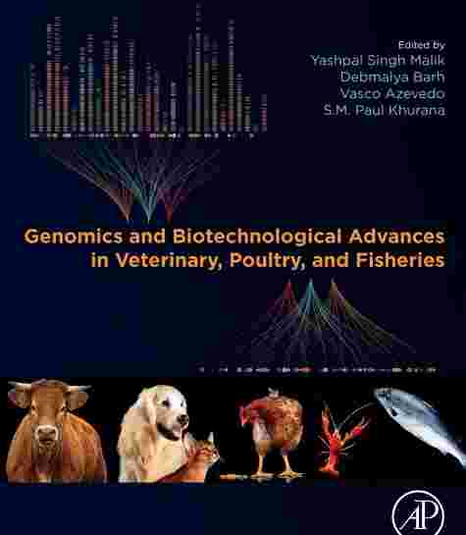
2 | Veterinary Clinical Epidemiology: From Patient to Population | Ronald D. Smith | http://libgen.gs/ads.php?md5=1e6d8ef66cf841e5096b20064c19d624 | 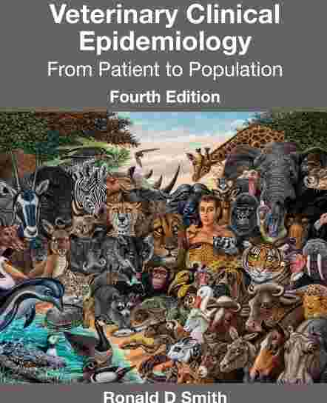
3 | Tasks for the Veterinary Assistant | Teresa F. Sonsthagen | http://libgen.gs/ads.php?md5=1b77a78dc0d77b62f1f52bcba7347d85 | 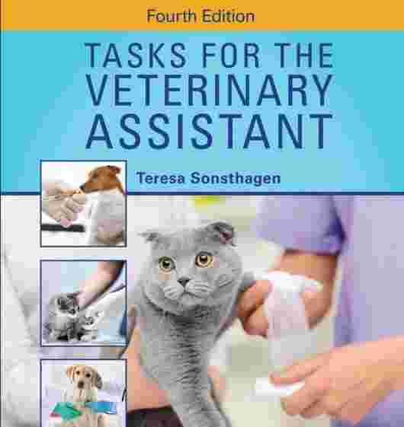
4 | Veterinary oral and maxillofacial pathology | Jason W. Soukup; Cynthia M. Bell; Brain Murphy | http://libgen.gs/ads.php?md5=f3cb4ae4b7c55bd25306eef445c17cc2
5 | 555 Questions in Veterinary and Tropical Parasitology | Hany Elsheikha; Xing-Quan Zhu | http://libgen.gs/ads.php?md5=69b06ebf4142603f4a038806b6e4f8b8 | 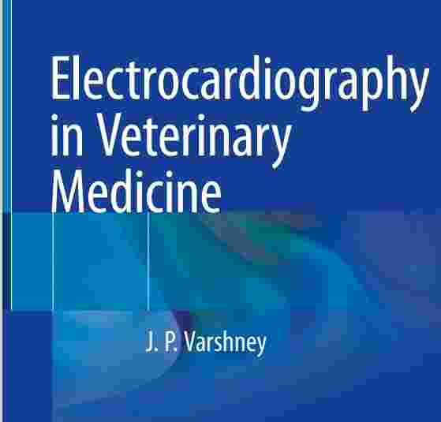
6 | Medical management of wildlife species : a guide for veterinary practitioners | Erica A. Miller (editor); Michael J. Yabsley (editor); Sonia M. Hernandez | http://libgen.gs/ads.php?md5=7eaaa98a7bbc2192ee59ae59f5cdb704 | 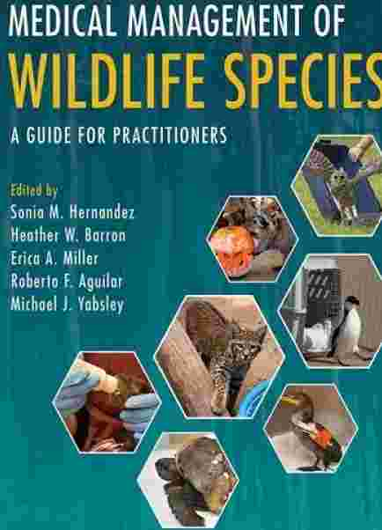
7 | Decoding Your Cat | American College of Veterinary Behaviorists | http://libgen.gs/ads.php?md5=418b86eff0f32d8a55a87fce5abeaf49 | 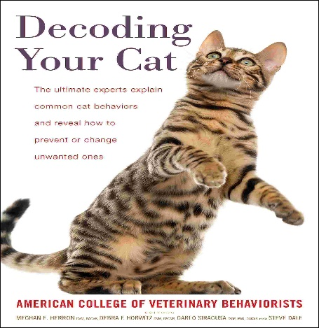
8 | Veterinary Cytology | Leslie C. Sharkey, M. Judith Radin, Davis | http://libgen.gs/ads.php?md5=9647fab0ebf649da4508a54bdbf65be6
9 | BSAVA Small Animal Formulary, 10th edition - Part A: Canine and Feline | Fergus Allerton | http://libgen.gs/ads.php?md5=3c281281f3f9a48799ddf6929a53763c | 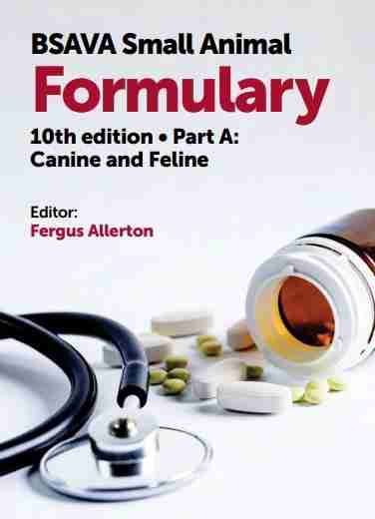
10 | BSAVA Small Animal Formulary, 10th edition - Part B: Exotic Pets | Joanna Hedley | http://libgen.gs/ads.php?md5=25a9a746134dc225dba56f27bc667d9f | 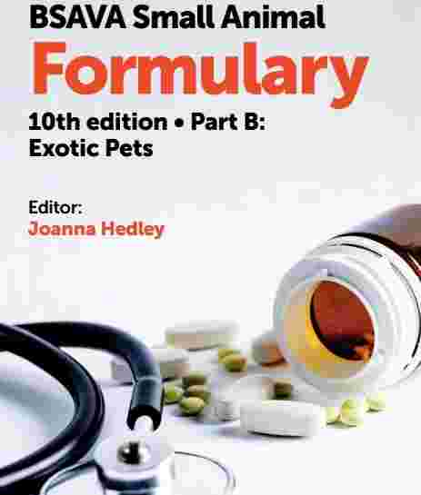
11 | Introduction to animal and veterinary anatomy and physiology | Aspinall, Victoria; Cappello, Melanie; Phillips, Catherine | http://libgen.gs/ads.php?md5=aff12224092cf579bb45fc6ef1bffca8 | 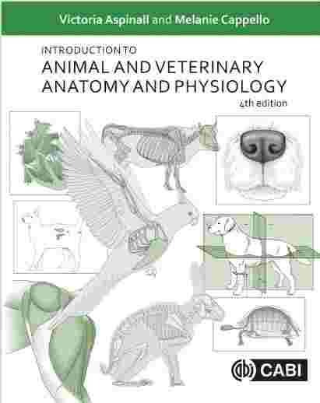
12 | Veterinary Anatomy of Domestic Animals: Textbook and Colour Atlas | Horst Erich König, Hans-Georg Liebich | http://libgen.gs/ads.php?md5=9e090dc0e29e4f76c9bd65009d72ce9b | 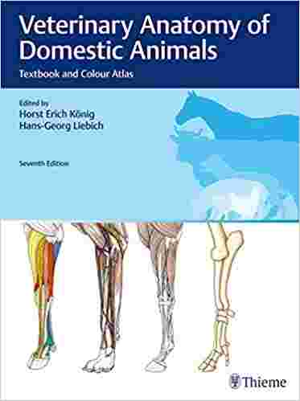
13 | Electrocardiography in Veterinary Medic | J.P. Varshney | http://libgen.gs/ads.php?md5=09d2365169818fdb54137b6a525895ff | 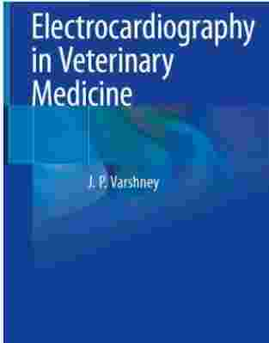
14 | Diseases of Poultry: 2 Volume Set | David E. Swayne (editor), Martine Boulianne | http://libgen.gs/ads.php?md5=caa54b7b79e8349051e7899ba6b3838e | 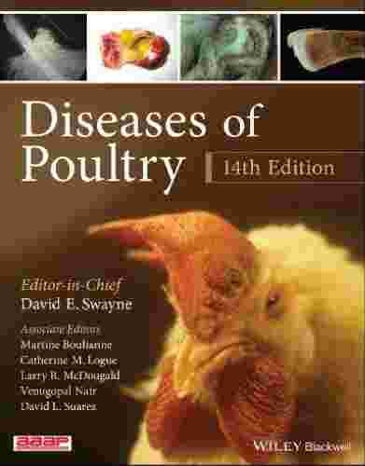
15 | Diseases of poultry | David E. Swayne | http://libgen.gs/ads.php?md5=18222dc8e86fd2e745f409c2b8fc97ff | 